DESIGNATION - W 85 RESET 1932
PID - GU1080

N 36 58 09.3

W 120 04 06.1

Recovered as described.

Additional recovery notes:
To reach from intersection of Cleveland Dr. and Hwy 99 go east on Cleveland for 0.1 mile to Gateway Dr. on the right (at Mobile Station). Turn right (south) and go 0.6 miles to a bridge over the Fresno River and the station on the left.

Station is a 12 inch by 12 inch trapezoidal concrete monument located 5.7 feet east of a steel guardrail, 21.5 feet east of the C/L road and 81.3 northwest of a power pole (no. 5109).
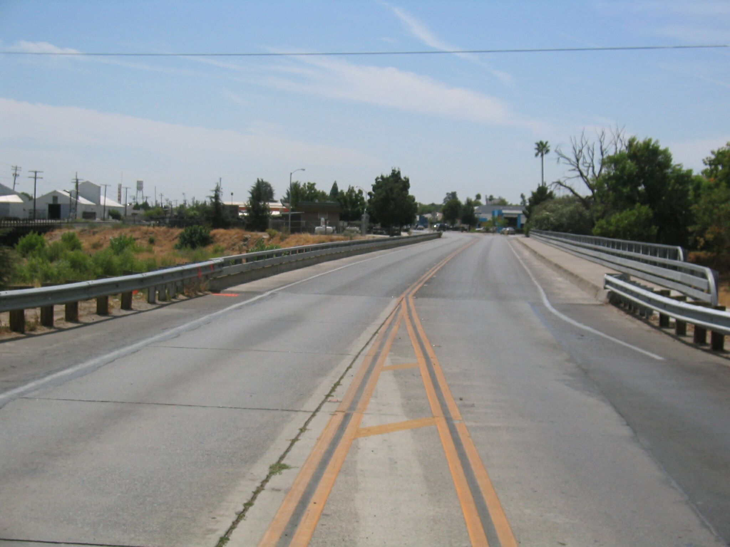
Mon

