DESIGNATION - R 817 RESET
PID - HS1080

N 37 05 01.2

W 120 18 22.3

Recovered as described.

Additional recovery notes:
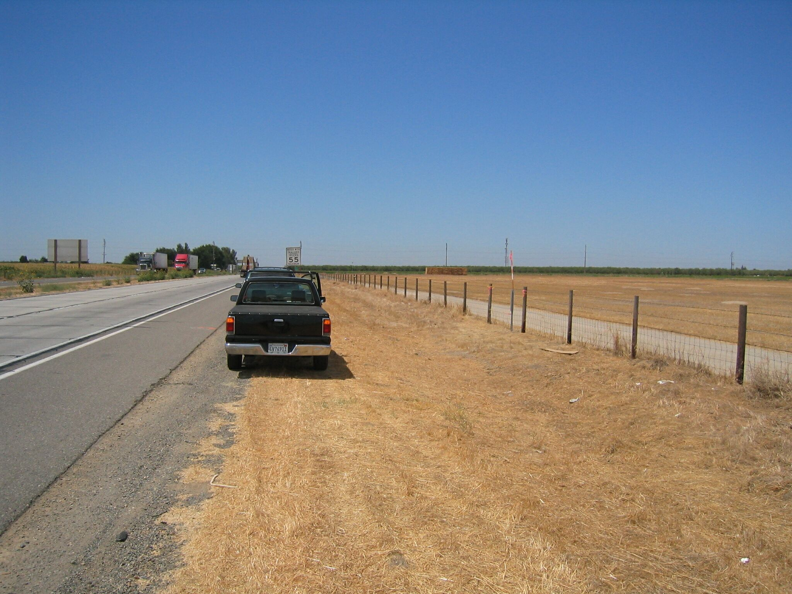
Mon

