DESIGNATION - MID2
PID - FU2814

N 35 43 55.7

W 119 44 29.6

Recovered 07-29-2003

Additional recovery notes:

Mon set flush with ground

Station is located west of I-5 at the Twisselman Road exit. Station is located at the end of the southbound exit ramp at Twisselman Road on the right (west). Station is in the northwest quadrant of the intersection.

To reach from the intersection of I-5 and Twisselman Road go west on Twisselman Rd. 0.1mi to the end of the Southbound exit ramp from I-5 and the station on the right.
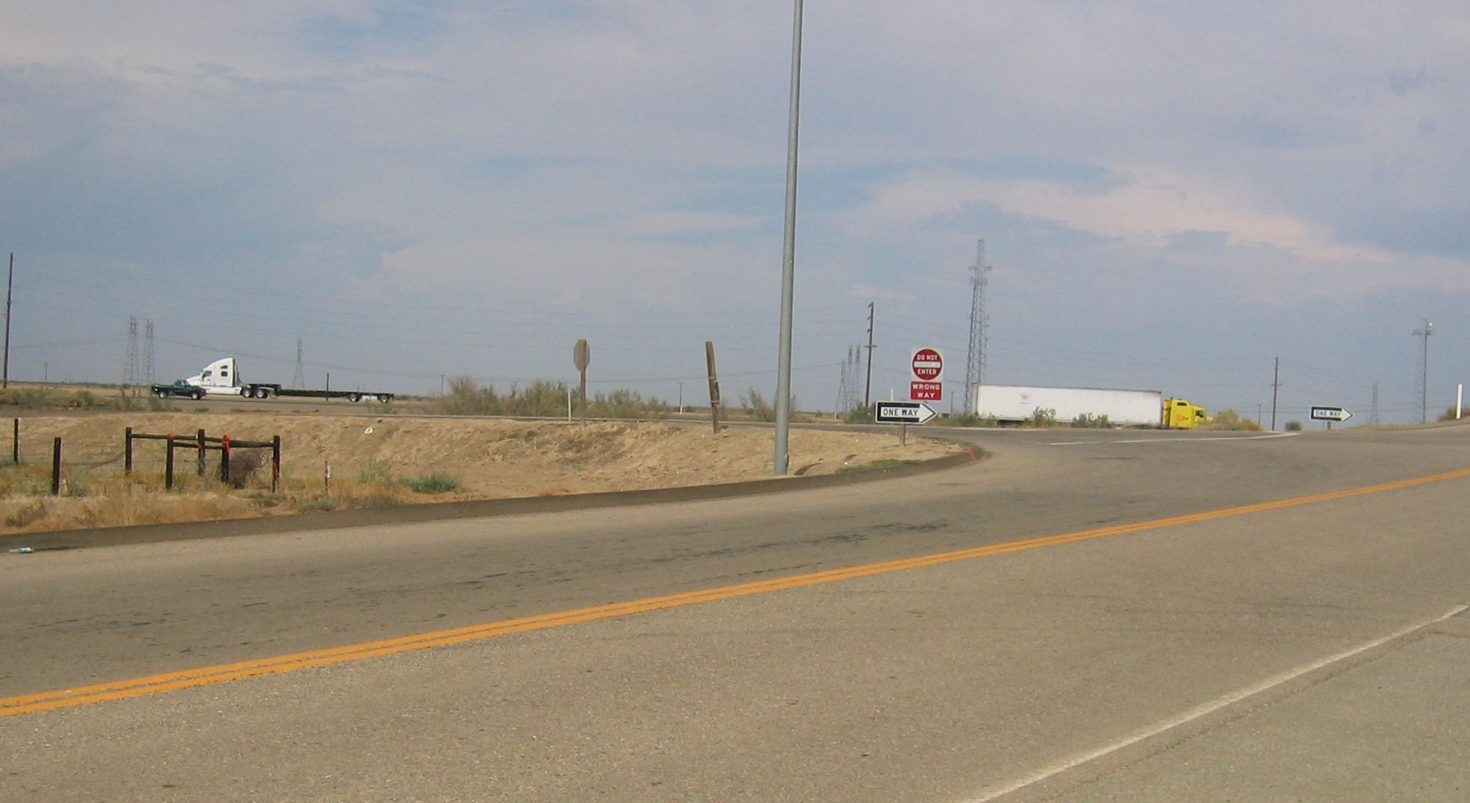
MON

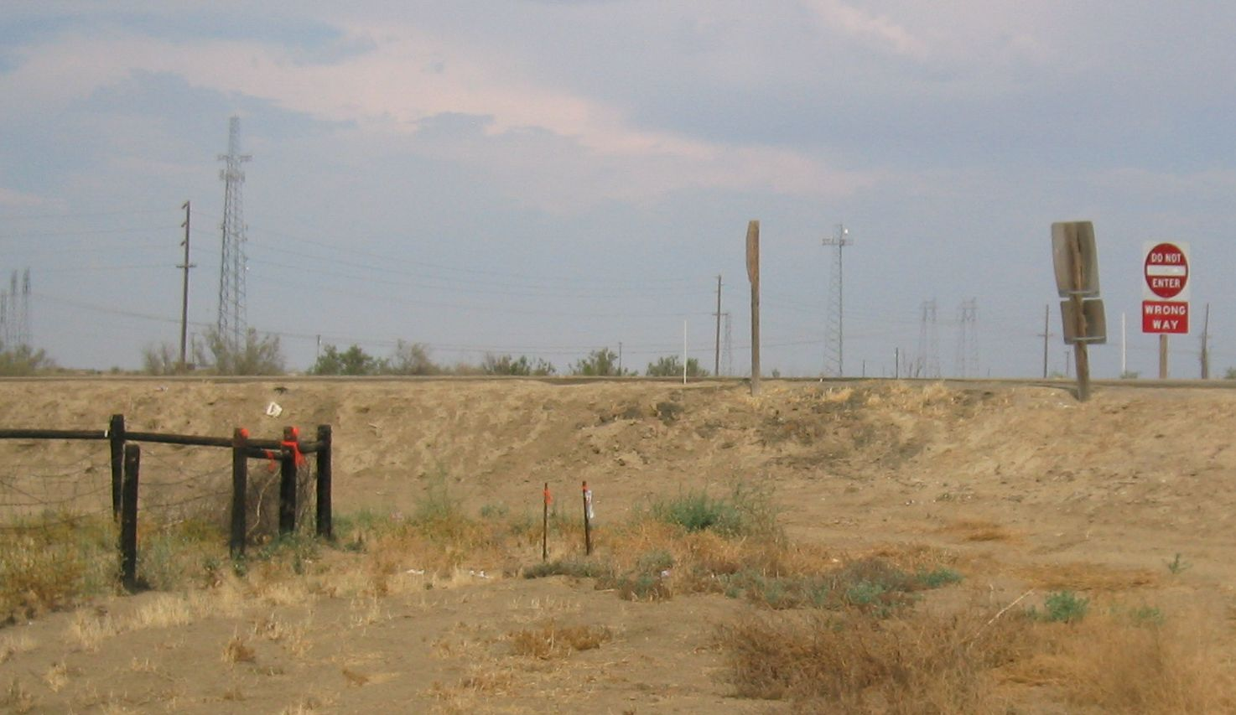
MON

