DESIGNATION - 191.6 A
PID - FU2884

N 35 47 24.0

W 119 52 10.3

Recovered as described 07-29-2003

Additional recovery notes:
To reach from the Twisselman Rd. exit on I-5 go west for 3.7 miles from the intersection of Twisselman and I-5 to the California Aqueduct crossing. Continue West on Twisselman 3.7 miles to King Rd a paved road right. Turn right and go north 3.1 miles to the Paramount Farms King Processing Facility on the left and where King Rd bears left (northwest) and a dirt side road continues north. Continue north on the dirt side road for 1.1 miles to the Aqueduct crossing. Cross the Aqueduct to the station on the left located on the Aqueduct bridge wing wall. Station is 11.9 feet north of the C/L of the aqueduct over-crossing and 41 feet west of the C/L of the east levee Rd.

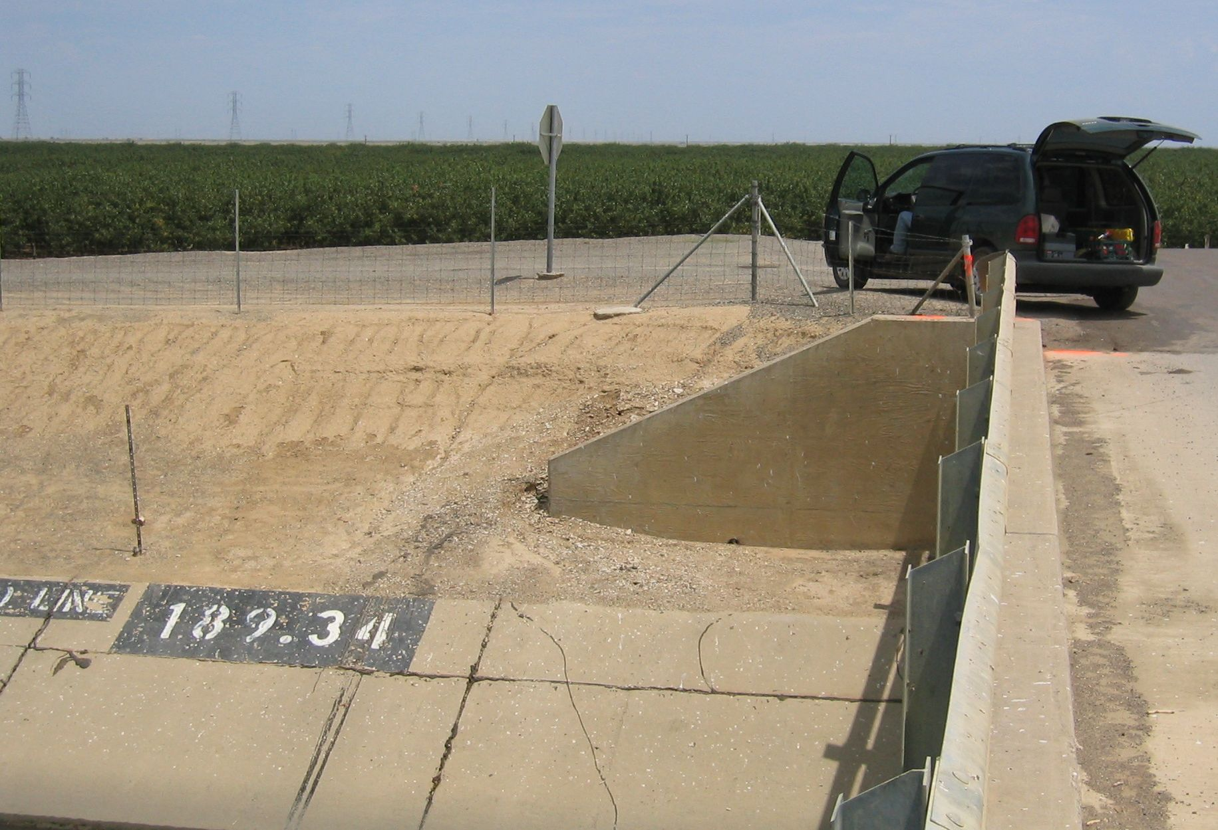
MON

