Extended RYO (ERYO) Protocol
Yehuda Bock
Scripps Institution of Oceanography
La Jolla, California
ybock@ucsd.edu
August 7, 2012
Version 2.3

Background
This document describes a binary data format for high-rate geodetic positions/displacements from GPS/GNSS observations, designed for a real-time environment. It is suitable for output of both network positioning (NP) and precise point positioning (PPP) approaches as well as displacements (and velocities) derived from GPS/seismic integration. The format is extensible as indicated by examples in the “comment” column of the tables in this document. It evolved from the RYO position message protocol (RTD User Manual version 3.5, 2007) and efforts as part of a three-year collaborative NASA AIST-08 project of SIO (Yehuda Bock, Mindy Squibb), JPL (Sharon Kedar) and Caltech (Rob Clayton, Ellen Yu). The protocol was further refined after community feedback at the Real Time GPS Workshop held in Boulder, Colorado on March 26-28, 2012.

We use the ERYO protocol to stream real-time single-epoch network positions from the California Real Time Network (CRTN - http://sopac.ucsd.edu/projects/realtime/) to external programs and applications using TCP/IP protocol. The Southern California Earthquake Data Center (SCEDC) at Caltech has the ability to read ERYO data streams and convert them to seismic formats (SAC, MiniSeed). SCEDC has written several programs in support of this effort: (1) getgps listens to an IP port at SOPAC and copies GPS and/or GPS/Seismic displacement waveforms into a staging pool at the SCEDC; (2) ryo2mseed converts the native ERYO format to seismic mSEED format; (3) archiveGPS takes new mSEED files and copies them to the SCEDC waveform archive and database, making these waveforms searchable; (4) STP is a client application that retrieves waveforms from the SCEDC archive for the user. The waveforms are also available through STP (http://www.data.scec.org/research-tools/AIST/AISTstp.html). We have transitioned at SOPAC and SCEDC to a wavepool model for the transfer of hour-length ERYO files, in case of a TCP/IP disconnect.

SOPAC monitors the ERYO data streams once every 5 minutes as part of the California Real Time Network (CRTN) project (http://sopac.ucsd.edu/projects/realtime/). ERYO streams are also read by NASA’s QuakeSim (http://www.quakesim.org/) project (Andrea Donnellan), having been implemented by Galip Aydin and Marlon Pierce at Indiana University (Aydin et al., 2007). ERYO streams, the result of a Kalman filter combination of GPS displacements and accelerometer data, will be used for the Bay Area Regional Deformation (BARD) network.

ERYO Position Message Protocol
ERYO’s various elements are shown in tabular format with 4 columns in each table. All messages consist of a common header, a data section and a checksum. The header has a fixed length of 5 bytes consisting of a 2-byte sync marker, a 2-byte data count, and a 1-byte message ID. The data section is of variable length depending on the message, and the checksum is two bytes. Note that the byte order in which a sequence of bytes is stored as Big Endian. The order of bits within a byte is stored as LSB0 (http://en.wikipedia.org/wiki/Bit_numbering). All integer types are unsigned except where specified (i.e., for satellite elevation angle).

Message Header Structure
Each ERYO message contains a 5-byte header shown below:

Parameter | Type | Description | Comments
Sync Marker | Two 1-byte integers | Always set to 0x9C, 0xA5
Byte count | 2-byte integer | The total number of bytes in the message including this header and the checksum
Message ID | 1-byte integer | A bit field indicating type of RYO message:  Bit 0 set: NEU derived from acc/gps combination  Bit 1 set: Velocity derived from acc/gps combination  Bit 5 : 0 = network positioning  1= point positioning  Bit 7 : 0 = real-time  1 = post-processing | i.e. 0 for this byte indicates xyz and single neu values per epoch from real-time with network positioning

Checksums
The two-byte checksum following the data section of the message is defined as follows: a 16-bit checksum is the 16-bit sum of all the unsigned 8-bit bytes starting at the beginning of the block, any overflow or carry to the 16-bit sum is discarded immediately. Therefore, it adds unsigned bytes to produce a 16-bit result. The following C++ code can be used to compute a checksum:
unsigned short RYOChecksum(const unsigned char *a_pbyBuffer,
unsigned int a_nByteCount)
{
unsigned short nChecksum = 0;

const unsigned char *pB = a_pbyBuffer;
for (unsigned int nByte = 0 ; nByte < a_nByteCount ; nByte++)
{
nChecksum = (unsigned short)(nChecksum + *pB);
pB++;
}
return nChecksum;
}
ERYO Position Message (Message ID 0x01)
The ERYO position message contains Cartesian ECEF (Earth-Centered Earth-Fixed) X,Y,Z positions and troposphere zenith delay parameters (T). It also optionally contains X,Y,Z variance/covariance, tropospheric variance/covariance, and satellite PDOP, azimuth, and elevation. A covariance with zero value indicates that the parameter is fixed or not estimated.
Mandatory parameters:
Parameter | Type | Description | Comments
Version Number | 1-byte integer | Version number for ERYO format multiplied by a factor of 10. Minor changes will result in an increase in 0.1 units; any change in byte structure will result in an increase of 1 unit. | 10: version 1.0  20: version 2.0  21: version 2.1
GPS week | 2-byte integer | GPS week for the position
GPS millisecond of week | 4-byte integer | The millisecond of the given GPS week for the position
Site index | 2-byte integer | Index of the site to which this position applies at the current epoch – Counting starts with 1 | For PPP, enter 1;  For network positioning (NP), enter the sequential number of a site within a network; The first site is always the reference site for NP
Number of sites | 2-byte integer | The total number of sites for which a position message is being sent at the current epoch | For PPP, enter 1;  For NP, enter number of sites in network
Site ID | 8-character string | The site ID to which the position applies, normally a 4-character alphanumeric string. | e.g., use 4-character site code
Solution Identifier | 8-character string | Name of group that is computing the displacements and transmitting the ERYO message | e.g., CRTN, BARD, PBO
Terrestrial Reference Frame | 1-byte integer | The ECEF reference frame | 0: ITRF2005/IGS05  1: ITRF2008/IGS08  Define further codes as needed
Ambiguity Resolution | 1-byte integer | 0 : Undetermined  1 : Ambiguity free solution  2 : Ambiguity fixed solution | [YB] These can be modified or expanded to denote different quality information.
Site Position and Troposphere Delay  (meters) | Array of four 8-byte double precision floating point numbers | The ECEF X,Y,Z values of the position at the current epoch, followed by the tropospheric zenith delay
Flags | 1-byte integer | A bit field indicating optional data blocks follow in the message:  Bit 0 set: XYZ covariance block follows  Bit 1 set: Tropospheric covariance block follows  Bit 2 set: Satellite information block follows  Bit 3 set: NEU displacement block follows  Bit 4 set: Velocity block follows  Bit 5 set: NEU variance &covariance  Bit 6 set: Vel variance & covariance | Could define and add additional blocks, for example, a block for site metadata – a block for a lower order bit must appear before a block with higher order bit

Optional Position Variance/Covariance Block (present if bit 0 is set in Flags):
Parameter | Type | Description | Comments
Scale factor (meters**2) | 4-byte single precision floating point | Used to scale uncertainties according to some criteria, e.g., weighted least squares | Also referred to as the chi-squared value, or variance of unit weight
X variance (meters**2) | 4-byte single precision floating point | Variance of X-component
Y variance (meters**2) | 4-byte single precision floating point | Variance of Y-component
Z variance (meters**2) | 4-byte single precision floating point | Variance of Z-component
YX covariance (meters**2) | 4-byte single precision floating point | Covariance of YX component
YZ covariance (meters**2) | 4-byte single precision floating point | Covariance of YZ component
ZX covariance (meters**2) | 4-byte single precision floating point | Covariance of ZX component

Optional Troposphere Variance/Covariance Block (present if bit 1 is set in Flags):
Parameter | Type | Description | Comments
T variance (meters**2) | 4-byte single precision floating point | Troposphere delay parameter variance
TX covariance (meters**2) | 4-byte single precision floating point | Troposphere delay parameter covariance with X component
TY covariance (meters**2) | 4-byte single precision floating point | Troposphere delay parameter covariance with Y component
TZ covariance (meters**2) | 4-byte single precision floating point | Troposphere delay parameter covariance with Z component

Optional Local Displacements (present if bit 3 is set in Flags):
Parameter | Type | Description | Comments
Reference X,Y,Z | Array of 3 8-byte double precision floating point | Reference ECEF value used for generating NEU values
Number of displacements (n) | 2-byte integer
N, E, U (m) | Array of n * 3 4-byte single precision floating point | Transformed from XYZ (see formula below) | Use WGS84 ellipsoid values to make this transformation – See Figure 1

Optional Velocities (present if bit 4 is set in Flags) derived from Accel and GPS:
Parameter | Type | Description | Comments
Number of velocities (n) | 2 byte integer
Velocity of N,E,U (m/s) | Array of n*3 4-byte single precision floating point

Optional Local displacement variance and covariance block (present if bit 5 is set):
N variance (m**2) | 4-byte single precision floating point | Variance of N-component
E variance (m**2) | 4-byte single precision floating point | Variance of E-component
U variance (m**2) | 4-byte single precision floating point | Variance of U-component
EN covariance (meters**2) | 4-byte single precision floating point | Covariance of EN component
EU covariance (meters**2) | 4-byte single precision floating point | Covariance of EU component
UN covariance (meters**2) | 4-byte single precision floating point | Covariance of UN component

Optional velocity variance and covariance block (present if bit 6 is set):
N variance (m/s**2) | 4-byte single precision floating point | Variance of N velocity
E variance (m/s**2) | 4-byte single precision floating point | Variance of E velocity
U variance (m/s**2) | 4-byte single precision floating point | Variance of U velocity
EN covariance (m/s**2) | 4-byte single precision floating point | Covariance of EN velocity
EU covariance (m/s**2) | 4-byte single precision floating point | Covariance of EU velocity
UN covariance (m/s**2) | 4-byte single precision floating point | Covariance of UN velocity

Optional satellite information header block (present if bit 2 is set in Flags):
Parameter | Type | Description | Comments
Number of satellites | 2-byte integer | The number of individual satellite information blocks to follow | This number could include the sum total across multiple constellations (e.g., GPS, GLONASS)
GDOP | 4-byte single precision floating point | Geometric Dilution of Precision

One block per satellite:
Parameter | Type | Description | Comments
Satellite constellation | 1-byte integer | 0 GPS  1 GLONASS  2 GALILEO | Expand definitions as needed
Satellite number | 1-byte integer | Satellite number within a particular constellation | e.g., PRN for GPS
Flags | 1-byte integer | Bit 0 on : ephemeris available  Bit 1 on : L1 track  Bit 2 on : L2 track  Bit 3 on : L5 track | Modify to include new signals from GPS and other constellations
Elevation (decimal degrees) | 1-byte (signed) integer | PRN elevation | -90° to +90°
Azimuth (decimal degrees) | 2-byte integer | PRN azimuth | 0°-360°

Conversion from ECEF (X,Y,Z) coordinates (e.g., ITRF) to local N,E,U frame
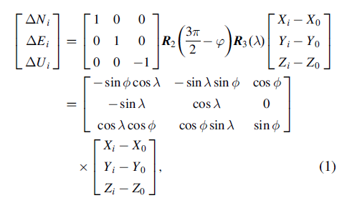
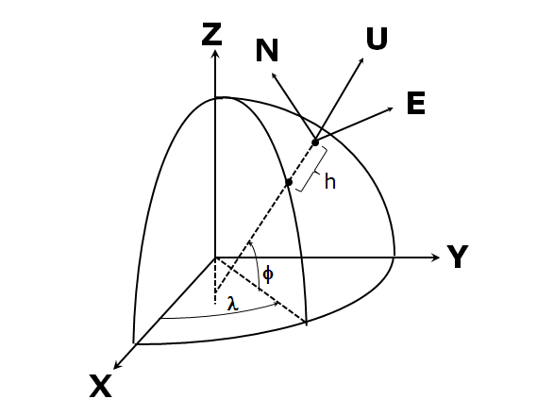
N, E, U is positive in the directions North, East and Up.

Acknowledgments
Funded by NASA/AIST Grant No. NNX09AI67G.
References
Aydin, G., Z. Qi, M. E. Pierce, G. C. Fox, and Y. Bock (2007), Architecture, performance, and scalability of a real-time global positioning system data grid, Phys. Earth and Planet. Interiors, 163, 347-359, doi:10.1016/j.pepi.2007.04.012.
RTD Version 3.5 User Manual, Appendix C (2007), Geodetics, Inc., San Diego, California, 238 pp.

Other suggestions:
Multipath, BINEX wrapper, RTCM wrapper

